Guide to Microsoft System Center Management Pack for SQL Server Dashboards
Microsoft Corporation
Published: June, 2017

The Operations Manager team encourages you to provide any feedbacks on the management pack by sending them to sqlmpsfeedback@microsoft.com.

Copyright
This document is provided "as-is". Information and views expressed in this document, including URL and other Internet website references, may change without notice. You bear the risk of using it.
Some examples depicted herein are provided for illustration only and are fictitious. No real association or connection is intended or should be inferred.
This document does not provide you with any legal rights to any intellectual property in any Microsoft product. You may copy and use this document for your internal, reference purposes. You may modify this document for your internal, reference purposes.
© 2017 Microsoft Corporation. All rights reserved.
Microsoft, Active Directory, Windows, and Windows Server are trademarks of the Microsoft group of companies.
All other trademarks are property of their respective owners.

Contents
Guide to Microsoft System Center Management Pack for SQL Server Dashboards 4
Changes History 4
Supported Configurations 7
Files in this Management Pack 7
Introduction to the Microsoft SQL Server Dashboards Management Pack 8
Datacenter View 8
Instance View 10
How to Create and Configure a Datacenter Dashboard 14
Create Datacenter and Instance Dashboards 14
Adjust Datacenter Dashboard 15
Adjusting Instance Dashboard 26
Move the Tiles 35
Performance View and Health Explorer 35
Bulk Add Tiles 35
Instance Dashboard Navigation 37
Configure Run As Profiles 41
Known Issues and Troubleshooting 42

Guide to Microsoft System Center Management Pack for SQL Server Dashboards
This Management Pack represents an accessible SQL Server Dashboards template designed to create and customize visualizations for any of your tasks.

Changes History

Release Date | Changes
June, 2017 (version 6.7.31.0 RTM) | - No changes introduced; increased the version number to 6.7.31.0 to comply with the current version of SQL Server management packs
May, 2017 (version 6.7.30.0 CTP) | - No changes introduced; the version is increased to comply with the current version of SQL Server management packs
March, 2017 (version 6.7.20.0 RTM) | - No changes introduced; the version is increased to comply with the current version of SQL Server management packs
February, 2017 (version 6.7.16.0 CTP) | - No changes introduced; the version is increased to comply with the current version of SQL Server management packs
December, 2016 (version 6.7.15.0 RTM) | - Fixed: Tiles content is replaced with question signs after a long period of inactivity
October, 2016 (version 6.7.7.0 RTM) | - Fixed issue: expanding “arrow” has low-contrast color when a health group is collapsed in Instance view (High-Contrast #2 color scheme)  - Fixed issue: in Web console, Dashboards continuously send requests to the database  - Fixed issue: not the first object gets selected in the object list after drill-down  - Fixed issue: horizontal scroll position resets after refreshing the Instance view  - Fixed issue: “No Data” message is displayed on some tiles after upgrading Dashboards management pack from version 6.7.2.0 to 6.7.4.0 or later version  - Fixed issue: on Web console, Dashboards crash when drilling down from Datacenter view to Instance view  - Restored the correct group order in SQL Server Summary dashboard views
September, 2016 (version 6.7.5.0 CTP2) | - Improved Dashboards performance  - Fixed issue: Regular\Virtual group tile will show 0 objects if user adds a new group before the previous one has been saved  - Fixed issue: virtual group filtering for Generic Distributor does not work  - Fixed issue: tooltips on some menus appear in unexpected places  - Fixed issue: Web Console is crashing upon right-clicking the hamburger button  - Fixed issue: button captions are cropped in some dashboard localization packs  - Fixed issue: Instance dashboard displays data for the item that is the first in the list if no items appear after applying a filter  - Fixed issue: the first group object is not in focus after clearing “Filter” field if there were no search results  - Fixed issue: Summary dashboards appear to be in a strange state if one installs only Dashboards MP without SQL MPs  - Fixed issue: Bulk Add Tiles does not trigger the refresh action  - Fixed issue: object and alert counters of Virtual groups containing real groups display zeros  - Fixed issue: an error appears in Web Console when using keyboard for navigation in “Add Aggregated Monitor” dialog  - Fixed issue: unexpected scrolling behavior in the instance view when using mouse scroll  - Fixed issue: markup of the dialog for adding classes gets broken when the scrollbars are displayed  - Fixed issue: wrong width value of the Edit dialog  - Fixed issue: there is no refresh action after saving the edited Virtual Group configuration  - Fixed issue: white-screen exception when working with a dialog in Web console  - Fixed issue: Datacenter and Instance queries fail when a special set of classes is selected
June, 2016  (version 6.7.2.0 RTM) | - Changed some stored procedures to improve Dashboards performance
June, 2016  (version 6.7.1.0 CTP2.1) | - Improved Dashboards performance.
May, 2016  (version 6.7.0.0 CTP2) | - Added a feature to support Virtual Groups (groups defined by classes, not by real group instance). This will help users with partial access to use our predefined dashboards.  - Added a feature to Bulk Add tiles from the class definition.  - Added a feature to ignore some states while calculating the worst state for the Datacenter View State Tile; added a feature to set this ignorance up for each group  - Added a feature to show/hide Instance path in the list on the Instance view  - Added instance path to the Instance Details  - Implemented deferred loading of the instance tiles to make the instance view operation faster  - Implemented a new format for Dashboards configuration providing a smaller size and a single binding  - Implemented a converter from old to new format providing preservation of user changes  - Improved error reporting  - Improved performance of initial load process  - Improved data sources performance  - Improved performance of instance selection (made it asynchronous)  - Improved performance of Datacenter and Instance View Tiles, loading and loaded animations  - Fixed animation issues and minor visual glitches (positioning, size of elements, fonts, main loading animation)  - Updated Summary dashboard  - “Known issues and Troubleshooting” section of the guide is updated
April, 2016 (version 6.6.7.30) | - Fixed animation, styles and display issues  - Updated Path search and display  - Added removal of unused elements  - Fixed filter and search issues  - Fixed "Show/Hide Path" button in Silverlight  - Implemented a deferred loader  - Improved drilldown process  - Fixed group adding process  - Fixed HighLight; simplified tile adding process  - Added support for SQL Server Replication 2016 MP objects in Summary dashboard
March, 2016 (version 6.6.7.6 CTP1) | - Fixed “The client has been disconnected from the server. Please call ManagementGroup.Reconnect() to reestablish the connection” exception.  - Replaced 999+ presentation with a new one (26.2k)  - Added configurable rule to pre-aggregate data in the DW (see the corresponding Known Issue)  - Added second row in the instance view to show Path of the object, and allow searching by Path.  - Fixed tooltip presentation on the Instance view  - “Known issues and Troubleshooting” section of the guide is updated
November, 2015 (version 6.6.4.0) | - Fixed an installation issue on SQL Server 2008  - Fixed permission grants for Alert aggregation table
November, 2015 (version 6.6.3.0) | - Implemented batching to all data aggregation mechanisms to ensure low temp database space and log space usage  - Implemented a control bit to divide group from non-group references to save space in aggregated data storage
October, 2015 (version 6.6.2.0) | - Improved performance  - Objects with selected monitors are now displayed on the top of the tiles list while editing  - If there are no child elements, Related Objects tile is not displayed in Instance View.  - Added Dark, Light and Contrast themes.  - Introduced an interface upgrade allowing to display the Dashboard errors  - User rights are now considered in the Dashboard display: the user can see the groups according to his/her access level only; Read-Only mode is implemented, it provides basic functions only: navigation, changing of the personalization settings  - Fixed some UI errors, UI design upgraded  - Fixed synchronization errors of the personalization settings.  - Introduced a Dashboard feature allowing to display data from any nesting level within the widgets
June, 2015 (version 6.6.0.0) | Original release of this management pack

Supported Configurations
This management pack is designed for the following versions of System Center Operations Manager:
- System Center Operations Manager 2012 SP1
- System Center Operations Manager 2012 R2
- System Center Operations Manager 2016

A dedicated Operations Manager management group is not required for this management pack.

Files in this Management Pack
- Microsoft.SQLServer.Visualization.Library.mpb
- Microsoft.SQLServer.Generic.Dashboards.mp
- Microsoft.SQLServer.Generic.Presentation.mp

Introduction to the Microsoft SQL Server Dashboards Management Pack
Microsoft SQL Server Dashboards Management Pack provides an ability to create and customize visualization on the fly. There are two views in the SQL Server Dashboards; Datacenter and Instance. The Datacenter view is an aggregated view. The Instance level provides detailed information about the selected object.

Datacenter View
The Datacenter view is the home page of the Dashboard, which provides information about the datacenter health state in an aggregated way. It is possible to drill down from the Datacenter view to the Instance view in order to investigate the root cause of the issue. It is possibe to return to the home page from any Instance view by clicking the Home part of the navigation pane.
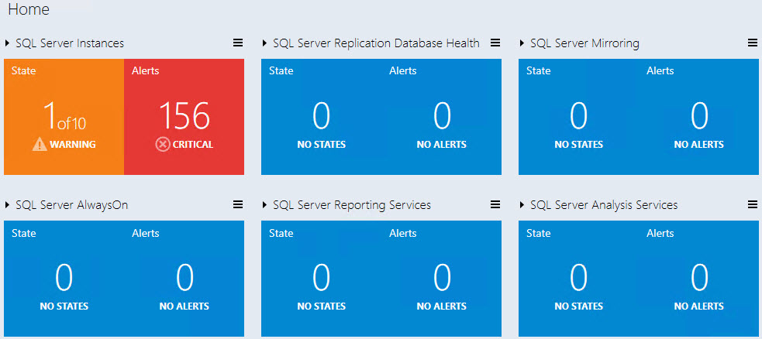

Datacenter View Tiles
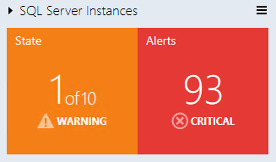
All group tiles on the Datacenter view are collapsed by default. A tile consists of two parts; the left part displays the number of objects within a group in the worst state and a total number of objects. The right part of the widget displays the number of alerts with the highest severity.

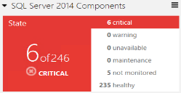
The expanded mode shows the number of objects in other states in addition to the data, which is displayed in the collapsed mode.

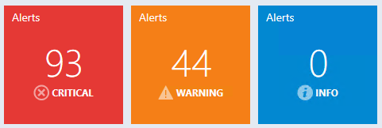
By default, the expanded mode displays three Alert widgets: Critical, Warning and Info. The number of alerts for each alert type is displayed within the corresponding widget.

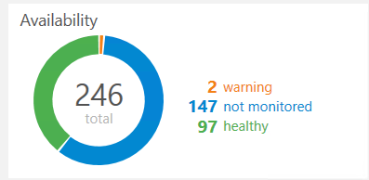
The Aggregated state monitor tile provides the number of the objects’ selected classes per state.

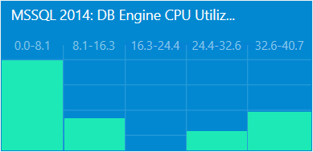
The Aggregated performance tile shows five columns each representing the number of the objects’ selected classes in the current data range.

Note
Use Datacenter View menu button or a group to add a new tile or group.
Note
It is possible to edit or remove the tile by selecting a corresponding menu item from the right-click context menu.
Note
Background color, time interval, and refresh rate settings applied to Datacenter View and all Instance Views can be set from the Datacenter View menu and Instance View menu.

Instance View
Instance view of the Dashboard opened while drilling into a group or an object from the previous Instance view or Datacenter Dashboard is provided below:
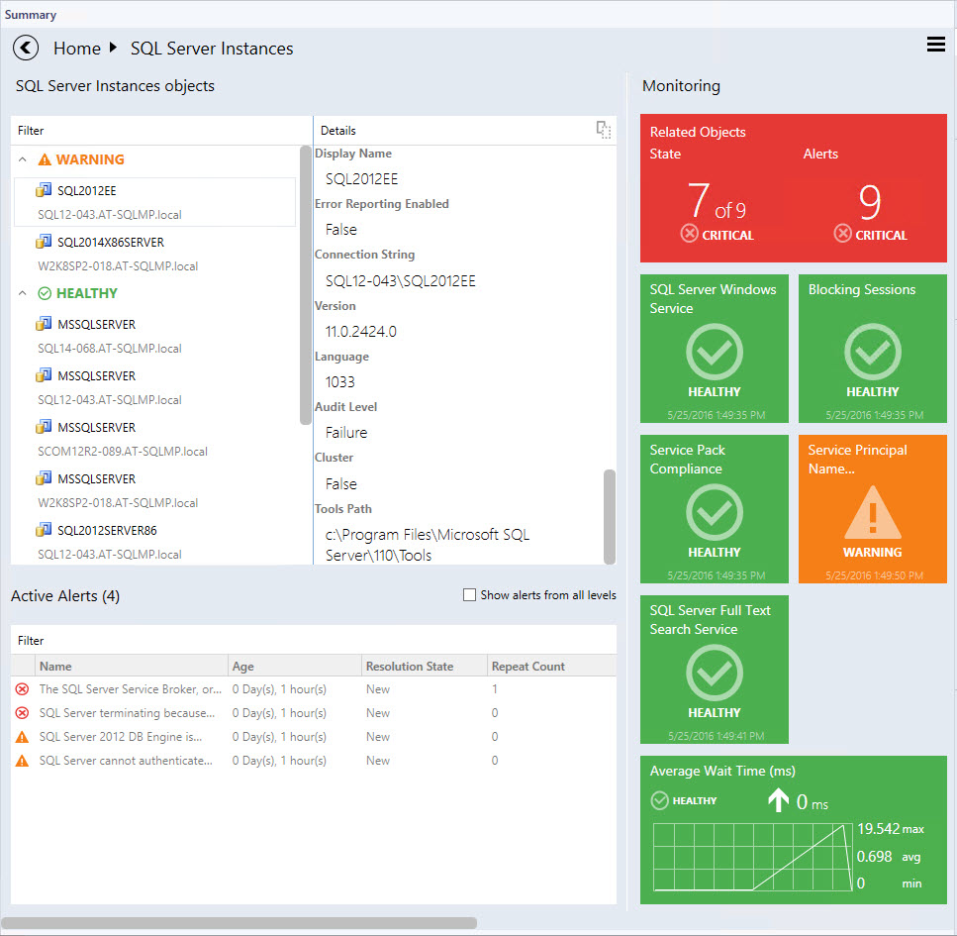
Note
Double-click the name of an object in the object widget to drill down to Instance Dashboard of the related objects (double-click Related Objects tile does the same). “Back” button is available in the upper-left corner of the navigation pane for navigating back to the previous Instance View.

Instance View Tiles
The tiles display information about the current state of the monitors as well as the latest performance data. Depending on the current state and the configuration, the tiles will have different background colors and layout. Please refer to examples below for illustrations of the tile capabilities.

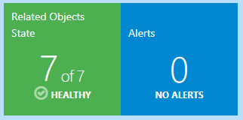
Related objects tile displays the number objects that are either hosted on the selected entity or linked by a containment. Double-clicking the tile opens Instance View for the related objects.

 | The monitor is in a critical state.
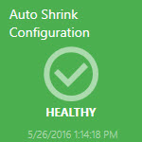 | The monitor is in a healthy state.  The monitor is in a warning state.
The monitor is disabled.

The monitor is unavailable.

The monitor is under maintenance.
 |  | The monitor is in a critical state. The data for the selected Time Range is being displayed.
 |  | The monitor is in a warning state. The data for the selected Time Range is being displayed.
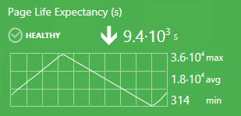 |  | The monitor is in a healthy state. The data for the selected Time Range is being displayed.
 |  | The monitor is disabled. The data for the selected Time Range is being displayed.
 |  | The performance counter has no correlated monitor (note that there is no icon in the top-right corner). The data for the selected Time Range is being displayed.
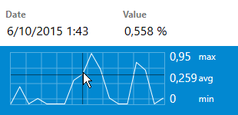 |  | It is possible to view the exact value of the performance metric by hovering the cursor over the performance chart.  The monitor is unavailable. The data for the selected Time Range is being displayed.  The monitor is under maintenance. The data for the selected Time Range is being displayed.

How to Create and Configure a Datacenter Dashboard

Create Datacenter and Instance Dashboards

Create a Custom Management Pack
It is recommended to store Datacenter Dashboards in a separate Management Pack to allow easy exporting and re-using of the configured views. To create a new management pack go to “Administration” tab, then click “Management Packs” item. Right-click “Management Packs” item, and then click “Create Management Pack”.

Create a Datacenter Dashboard
In order to create a Datacenter Dashboard, a user should select “SQL Server Dashboards” template from the like folder.

Open “New Dashboard and Widget Wizard”
Go to “Monitoring” tab and select the folder for a new Dashboard.
Right click -> New -> Dashboard View.

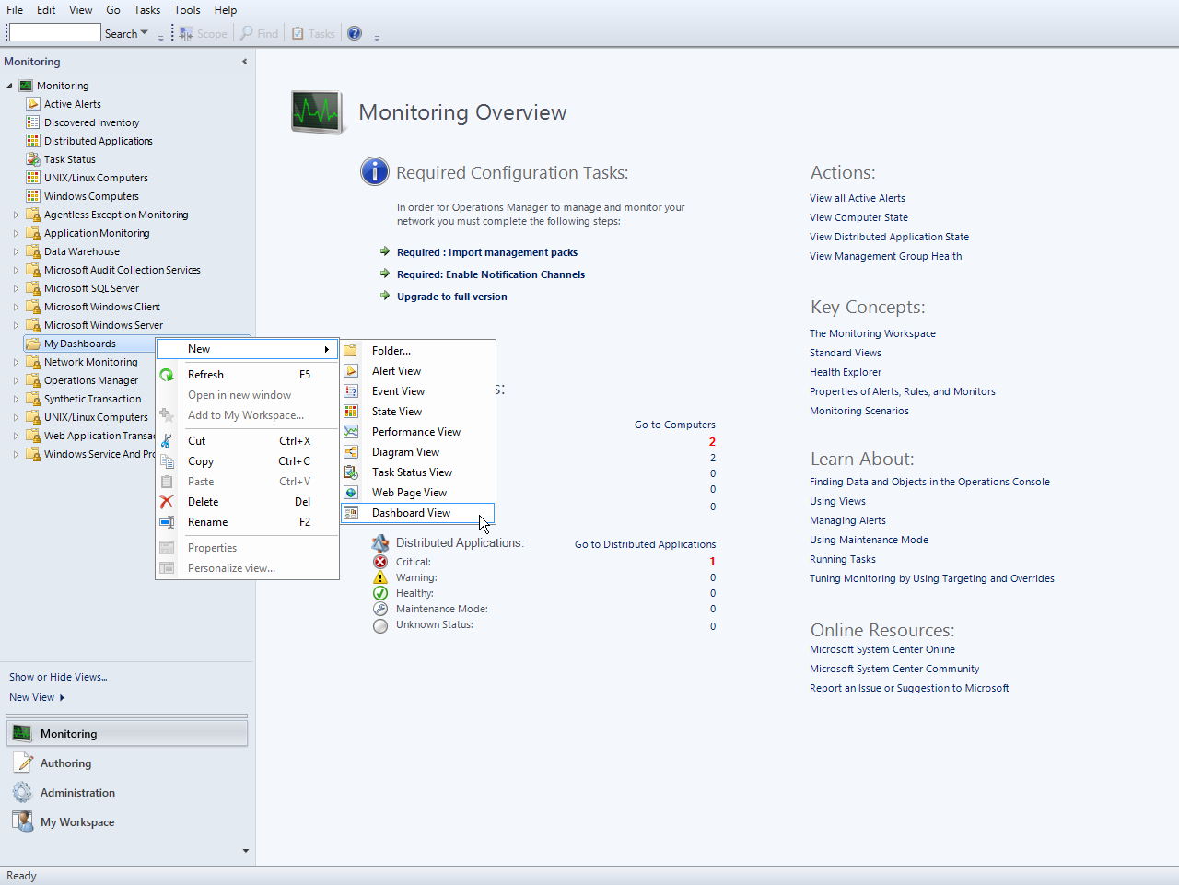

On “New Dashboard and Widget Wizard” page select “SQL Server Dashboards” template. Specify the new Dashboard name and Click “Create” button:

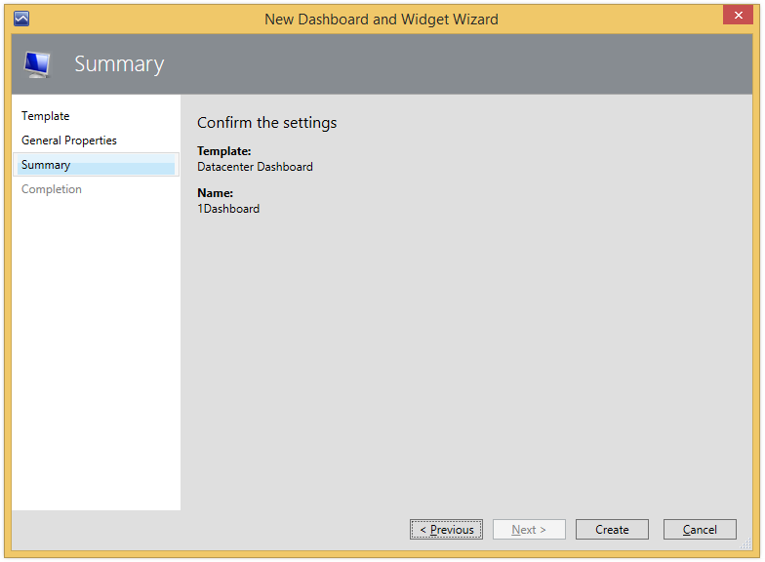

The name of the dashboard is used as a display name, while the description filed is not displayed on the dashboard.

Initial State of a Newly Created Datacenter Dashboard
A new Dashboard has no groups by default, and only “Home” note (not clickable) that represents the root of breadcrumbs and Datacenter Menu. Note that while the dashboard is in “Loading…” state, the Hamburger button and “Home” title are not displayed.

Adjust Datacenter Dashboard
To set up a Datacenter Dashboard, it is necessary to add some Groups and to provide corresponding widgets to each Group.

Personalization of Datacenter View
Datacenter Dashboard menu is accessible by left or right click on the menu button; it allows user to add a group, add a virtual group, configure the settings and refresh the Dashboard.

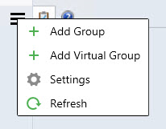

Available settings are as follows:
- “Refresh Rate” – this setting defines how often the Dashboard refreshes the data on a client. This setting does not change the actual collection frequency of metrics on a server. The refresh rate can be set as 5 (default), 15 and 30 minutes.
- “Time Interval” – this setting defines for which period the data should be displayed. The Performance widget on the “Instance” view depends on this setting. The time interval can be set as “Last Day”, “Last Week” and “Last Two Weeks”.
- “Background Color” – this setting allows changing the background color for all views.
- “Theme” – this setting allows choosing “Light” or “Dark” theme for the Dashboard. Background color can be changed manually.
- “Show instance path” checkbox is switched on by default (for more details, see SQL Instance path property section); when it is switched off, the “Show” title is changing to “Hide”.

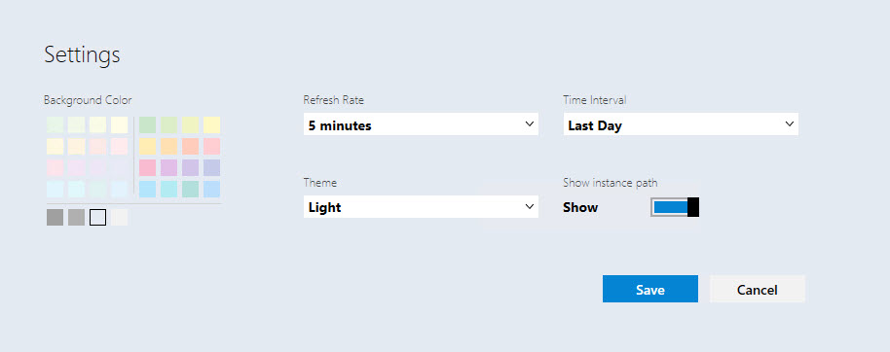

- “Contrast” theme is automatically activated, when the corresponding system theme is used. Background and font colors are picked from the system palette.

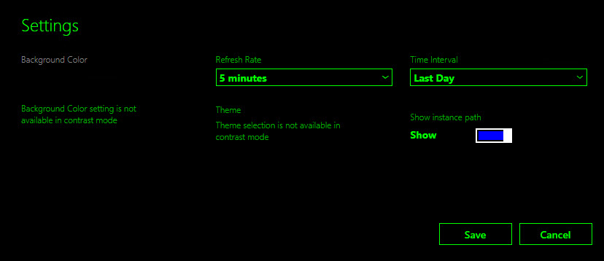

Add a Group
Click menu button and select “+ Add Group” item from the drop-down. It is also possible to search for the desired group in “Add group” dialog by typing a corresponding group name.
“Add Group” dialog requires “GROUP” ComboBox field and “DISPLAY NAME” field. When “GROUP” ComboBox field is in the focus, “It is required to select a group” hint is displayed. When “DISPLAY NAME” field is in the focus, “The field is required” hint is displayed. The “GROUP” ComboBox field is in the focus by default after opening “Add Group” view.
Note
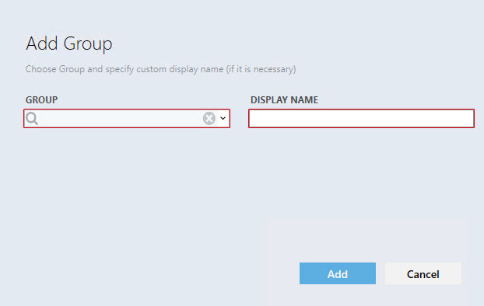
The red highlighting disappears only after entering valid data in the field.

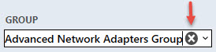
The user can open dropdown list of the available groups or type part of a group name and best match groups will be displayed in the dropdown list. The information entered in “GROUP” field can be deleted by pressing “X” button.

To select a group, choose one in the dropdown list (the groups in the dropdown list should be placed in alphabet order). “DISPLAY NAME” field should be populated with a name as well, unless the user has already defined a name.
If the selected group is already added on the board, “The name already exists” hint is displayed when “DISPLAY NAME” field is in the focus.
Note that “Add” button changes its state when it is disabled.
When Data Center dashboard is loaded for the first time or refreshed by the refresh option from Dashboard Menu, a special blink animation is displayed.

Note
It is possible to create a custom group and populate it with a desired set of objects. Refer to TechNet for guidance.

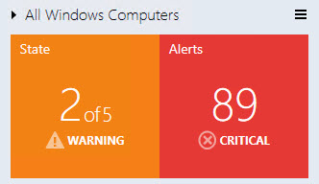
New added group is displayed in collapsed (minimized) state by default. To expand the panel click the arrow symbol on the right from the group name.

“State” part of the widget displays the worst state of its object, and it is colored according to the represented state (priority list looks like this: critical, warning, unavailable, maintenance, not monitored, healthy). Critical state is red, warning – yellow, unavailable – gray, healthy is green and the rest are blue. For alerts, priority/colors are as follows: critical - red, warning - yellow, info - blue.

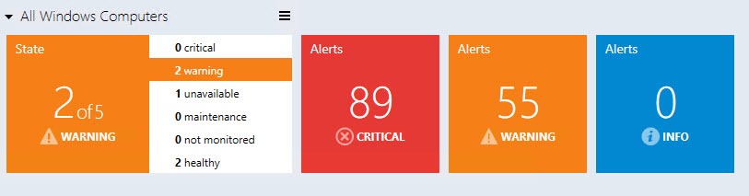
In Expanded Mode, State widget changes it representation.
It still displays the worst state and is colored according to the represented state (the priority list looks as follows: critical, warning, unavailable, maintenance, not monitored, healthy), but it also lists all possible states and shows the number of objects in the states.
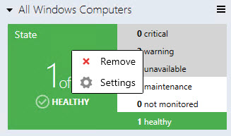
Context menu of “State” tile allows removing it and opening of Enabled States view.

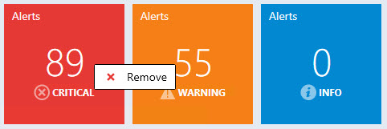
All other tiles (3 types of alerts) can be only removed in the context menu.

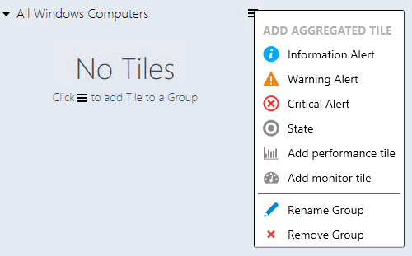
Note that if all tiles are removed, the group widget looks as follows:

Remove object dialog is similar for all tiles; the display name of the object to be removed differs only.
Alert widget in the expanded mode is separated by alert type. Red widget represents critical alerts, orange for warnings and blue widget for info.

Enabled States
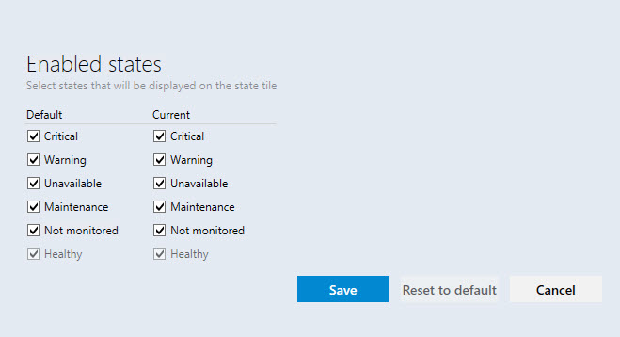
When the user chooses “Settings” item in the group context menu (right mouse click at the group), “Enabled states” view is opened

The user can select states of the group objects, which will be displayed on the state tile in this view
When the user changes “Default” checkboxes settings, “Current” checkboxes settings are changed for all groups in the current Dashboard View.
Note: If “Current” group checkboxes settings were changed previously, сhanging “Default” checkboxes settings will not affect “Current” checkboxes settings till “Reset to default” settings are applied to this group.
“Current” checkboxes settings applied only for the current Dashboard View group
“Enabled states” window has “Save”, “Reset to default” and “Cancel” buttons. “Esc” button causes cancel action, while “Enter” button saves the inserted data.
“Reset to default” button is disabled if “Default” checkboxes settings match with “Current” checkboxes settings
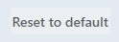

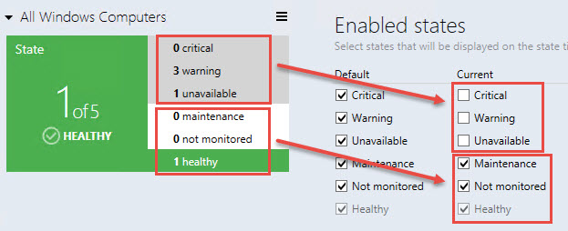
Note that the objects’ states unchecked at “Enabled states” view have gray backlight, and their states do not participate in forming of “State” tile.

Add Aggregated Tiles
Note
Aggregated tiles are available in Datacenter view only.
Left or right click on the group menu button calls “Add aggregated tile menu”.
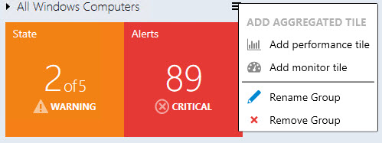
In this menu, the user can add performance tile, add monitor tile, rename and remove the group.

Add an Aggregated Monitor Tile
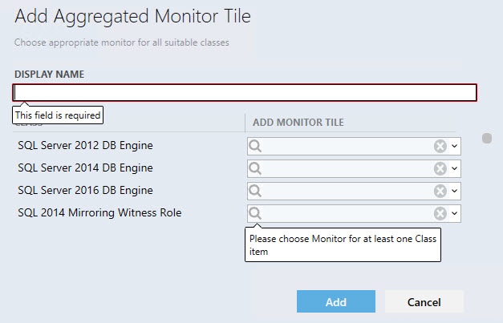
From Group options menu, the user may call “Add Aggregated Monitor Tile” dialog; while the content is being loaded, a pre-loader is displayed.

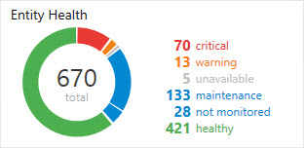
The left part of Aggregated Monitor tile consists of a colored donut, which displays relative share of objects in one state against objects in other states, with the total number of entities.

The right part of the tile has a list of states and the number of objects in the states. If there are no objects in a state, a line representing the state is not displayed. Hovering over donut`s part, its objects amount or state name changes the backlight.
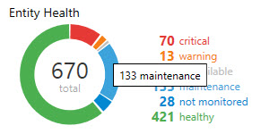
All aggregated monitor elements have corresponding tooltips:

Add an Aggregated Performance Tile
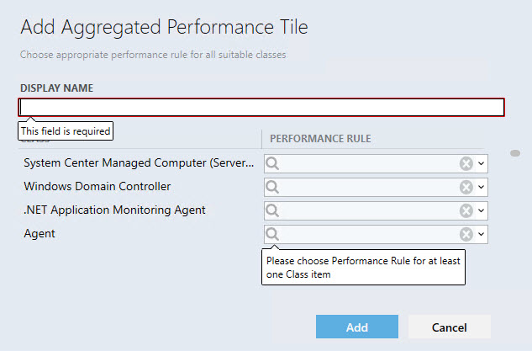
From Group options menu, the user may call “Add Aggregated Performance Tile” dialog; while the content is being loaded, a pre-loader is displayed.
Display name is a required field that will be automatically populated when the user selects a performance rule. Another selected rule will not override the field. Auto-fill mechanism does not work if the user has already populated the field.
“CLASS” column displays all classes the group contains. “PERFORMANCE RULE” column displays all performance rules of the class.
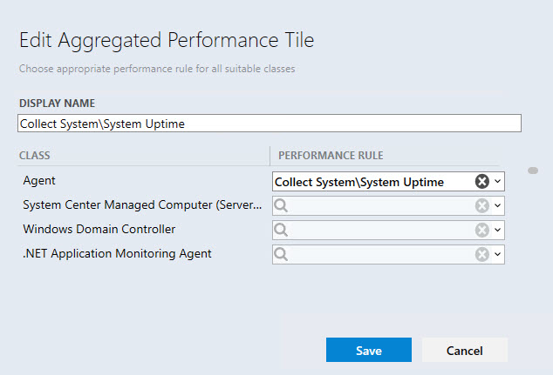
Note: if all class rules have the same prefix (e.g. “MSSSQL SERVER 2014:”) the prefix is not displayed. Parent classes are displayed firstly in alphabet order in “CLASS” list, and then children classes are displayed in alphabet order. Rules in “PERFORMANCE RULE” dropdown list are also displayed in alphabet order. The classes for which the rules have already been selected are displayed firstly.

“X” button wipes the selected data. Validation messages disappear when conditions are met.
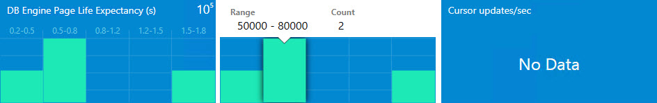
Enter and Esc buttons have Save and Cancel configuration correspondingly. When the user adds a performance tile into a collapsed group, the group is expanded automatically and the screen is centered on the widget.

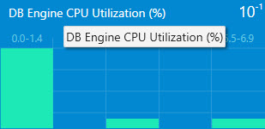
A performance tile has 5 columns. Each column represents a range of values. Upon hovering over a column, a tooltip with detailed information is displayed. In the top right corner of the widget, the degree of the values can be displayed. If chosen performance rule(s) return nothing, the widget displays “No Data” message. Values the widgets return appear to be the last values received from the agents. The Aggregated performance tile name has a corresponding tooltip:

Add a Virtual Group
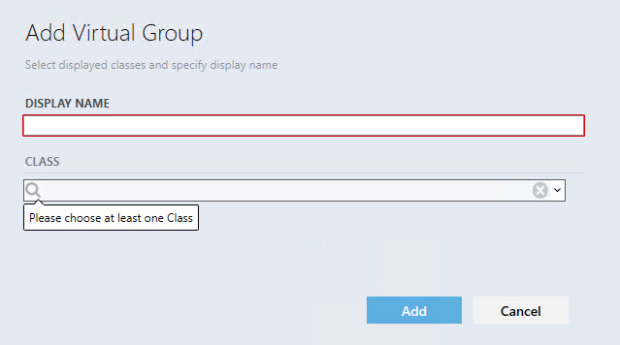
A virtual group with many classes can be added to Datacenter Dashboard.

Adjusting Instance Dashboard
Note
Instance tiles are available in Instance View only.

By double-clicking any group of a group widget or a virtual group, the user drill-downs to Instance Dashboard. The object tree is displayed at the top of the Instance Dashboard view

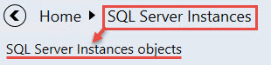
The user will see a list of group objects in the first level of the group or virtual group.

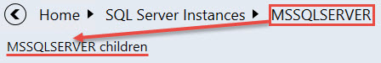
If the user drills-down into the group object, the list of group object children will be displayed:

Note that if the group object or its child does not have any child, the user can`t drill-down into it.
“Back” button opens previous Instance Dashboard. The user can click on any element to navigate directly to its dashboard. All objects of the group or children of the object are sorted by their state; the most critical ones are placed on the top of the list.
“Details” widget lists all properties of the selected entity. When the user opens the dashboard, the first element is selected automatically, but if the user selects another object, the selection remains even if a refresh event occurs.
By clickingicon in the header of the dashboard all data is copied into the clipboard. If the user hovers over a property in the details widget, a similar button is displayed in there to allow copying the property data.
Filter searches through entity name and entity path or thought entity name only

(It depends on the configuration of “Show instance path” checkbox in “Settings” view)
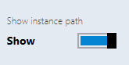
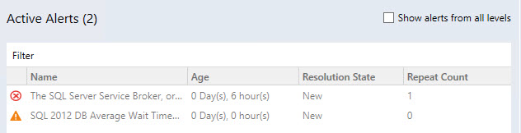
“Active alerts” displays all object alerts excluding the closed ones (custom alerts are displayed as well).

Note: number of active alerts is displayed in brackets next to the “Active Alerts” title

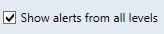
Object alerts and its children’s alerts are displayed if “Show alerts from all levels” checkbox is switched on.

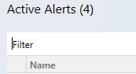
Alerts can be filtered by their names by means of “Filter” field.

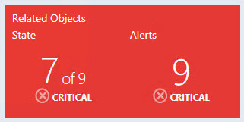
“Related objects” and “Alerts” tile is displayed by default and cannot be deleted. The tile has logic similar to aggregated state tile. By double-clicking on the tile, the user drills-down further to the children of the selected object.

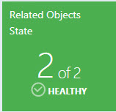
“Related objects” tile shows object’s next level children. The color of the tile complies the worst state color of its children. Under the name of the tile, the user can see amount of object children in the worst state and the total number of children. The state name and state icon of the worst object children state is displayed under the number of the object children.

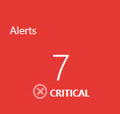
“Alerts” tile displays the amount of its children`s worst alerts + its children`s children worst alerts. The color of the tile complies the color of its children’s worst alerts. The severity name and severity icon of its worst children’s alerts is displayed under the number of alerts.

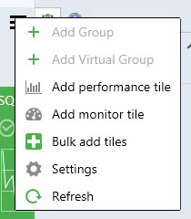
From the menu of Monitoring section, the user can add a performance tile, add a monitor tile, add performance and monitor tile by using “Bulk add tiles” view, customize dashboard view settings by using “Settings” menu and refresh dashboard view.

Double-clicking on performance tile opens Performance view. Double-clicking on monitor tile opens Health explorer.

Add a Performance Tile
Double-click the Group to drill-down from Datacenter to Instance level.
Click menu button to add a performance tile.
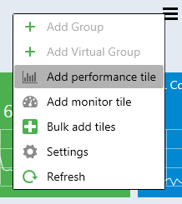

In “Add Performance Tile” dialog, select the desired performance tile.
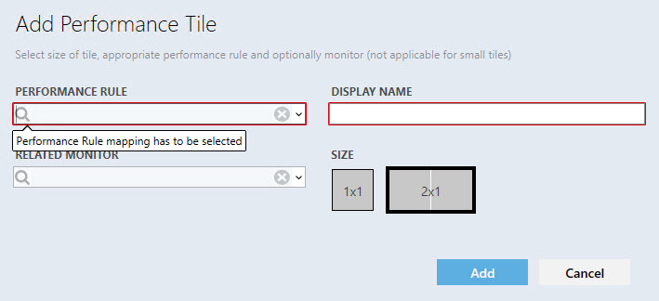
There are 3 types of performance tiles: 2x1 without a linked monitor, 2x1 with a linked monitor and 1x1 tile.
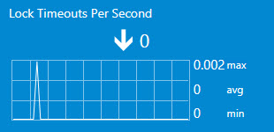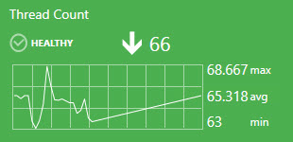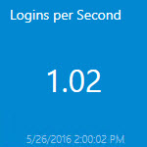

Display name is populated automatically when the user selects a rule for the first time. The drop-down supports advanced filtering options based on the entered text.
If the user adds same tile twice and uses automatic display name population, the date and time are added automatically to the rule\monitor name at the “DISPLAY NAME” field.

If all rules have similar prefix, the prefix is not displayed in the alike rules.
The circle with a cross removes all data from the field.
When a rule is selected, validation messages disappear and “Add” button becomes enabled. When the user tries to add performance tile with already existed “DISPLAY NAME”, a corresponding error tooltip message is displayed:
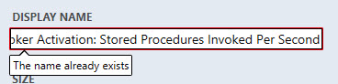
If the user selects a monitor, the tile would have linked monitor and the tile color will depend on the monitor state. If the user selected a monitor, but set 1x1 size right after, the data in the monitor field becomes disabled and is not saved in the configuration if the user added the tile, but becomes enabled again if the user returns 2x1 size.

Upon hovering over the graph, a tooltip with the date and value is displayed.
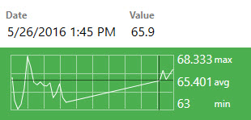

The widget has kind of trend line, which is represented by the arrow. Near the arrow, the user can see the last value of the index.

If the rule value has not been changed during the displayed period, the trend arrow is not displayed.

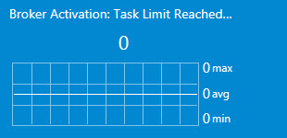

Note that if the index last value is too long to be fully displayed in the tile, it is displayed in the tooltip.
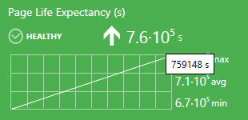

Minimum, maximum and average rule value is displayed near the chart.
Measurement units are displayed if the rule has them in its name in brackets.
The user can select a period to be displayed in the 2x1 tile chart of the dashboard view “Settings” menu.

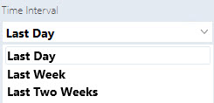

1x1 tile displays only the last value. The same data is displayed in the 2x1 version right under the widget name.

Please note that the last value of date and time is displayed under the rule last value in the 1x1 performance tile. If there is no data in SCOM database for the set period, the widget returns “No Data” message.

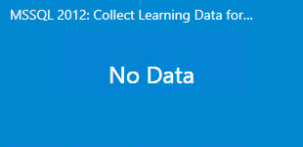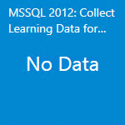

2 options are available by the right click on the tile: edit and remove.
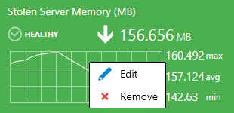

Add a Monitor Tile
Double-click the Group to drill-down from Datacenter to Instance level.
Click menu button to add a monitor tile.

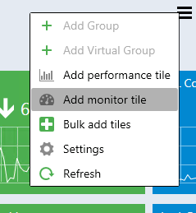

In “Add Monitor Tile” dialog, select the desired monitor.
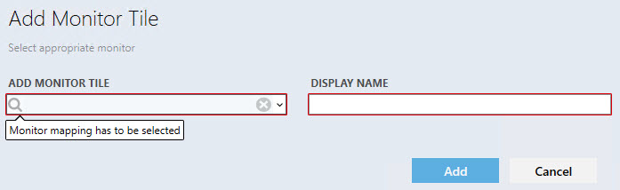

The control has logic similar to the performance dialog.

The monitor has a name, state indicator and the date when the state has been changed for the last time. Two options are available by the right click on the tile: edit and remove:
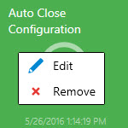

Move the Tiles
The tiles can be moved by means of drag-n-drop.
Datacenter Dashboards allow the following methods of tile moving:
- Moving of the groups in Datacenter View.
- Moving of the aggregated tiles within the expanded group in Datacenter View.
- Moving of the tiles in Instance View.

Performance View and Health Explorer
To open Performance View and Health Explorer, it is necessary to double-click the corresponding tile (performance tile and monitor tile respectively).

Bulk Add Tiles
The user can use “Bulk add Tiles” menu for quick adding of monitors and performance tiles in the instance view (all object rules and monitors are displayed in the “Chose tiles to be added to the view” list).

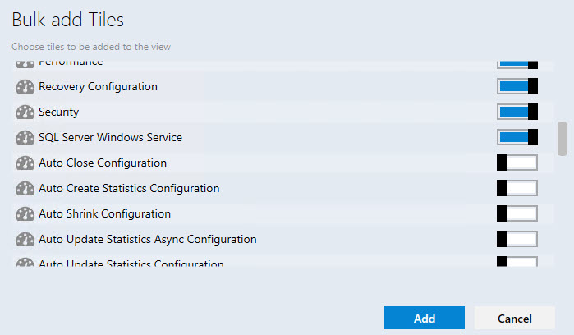

The checkboxes for already added tiles are switched off (monitor tiles, which are added as a part of 2x1 performance tile, are considered as already added)

Note that checkboxes are switched on for the tiles, which haven`t been added to the instance view yet.

Performance and monitor tiles have different icons:

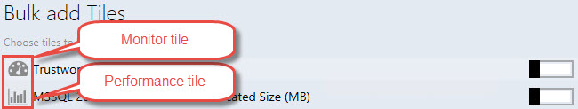

The same performance and monitor tiles can be added many times by means of “Bulk add Tiles” menu. The date and time parameters will be added to “DISPLAY NAME” for each subsequent adding of repeated performance\monitor tiles.

Instance Dashboard Navigation

Drill-Down to the Related Objects
Drilling-down can be performed as follows:
- Select an object from the left pane and double-click “Related Objects State” widget.

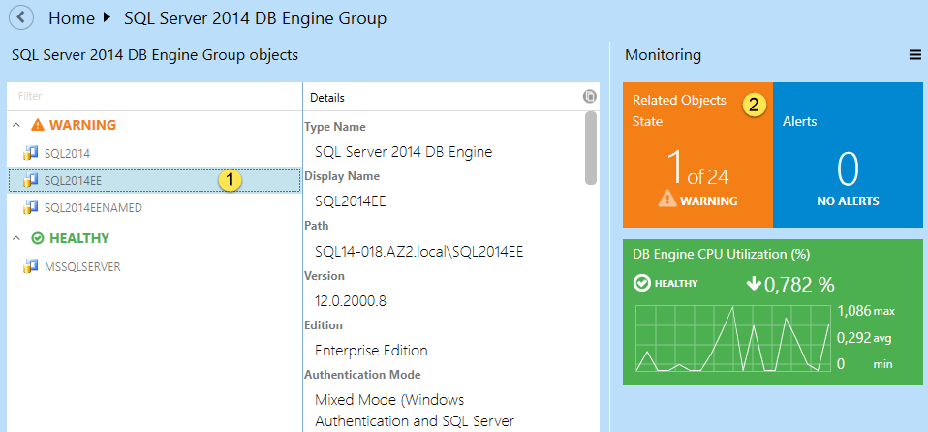

- Double click the object from the left pane.

Use “Show alerts” Function
The function allows seeing the list of alerts in the object. To activate the function check the corresponding checkbox.

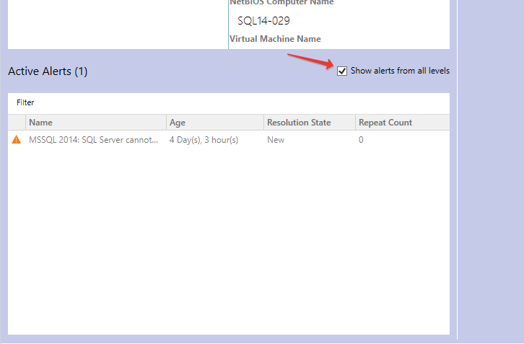

Using Navigation Pane
To move to any location in the path just click it. To move to the parent view click button.
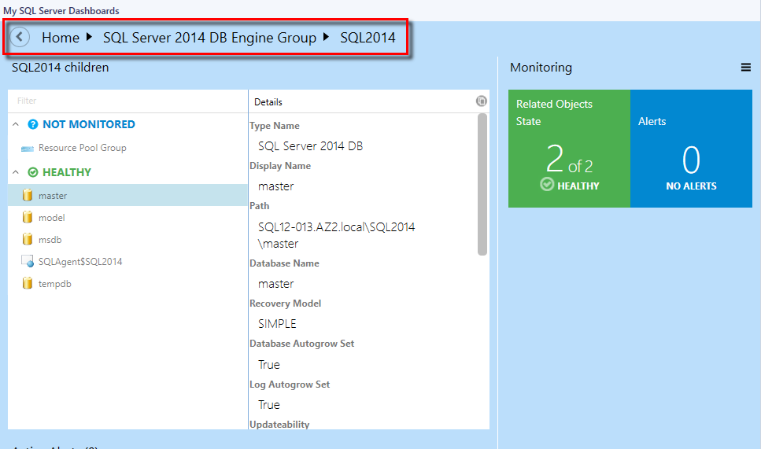

SQL Instance Path Property

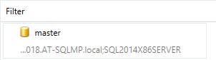

Dashboard object path is shown after switching on the “Show instance path” checkbox in the dashboard “Settings” menu:

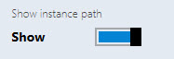

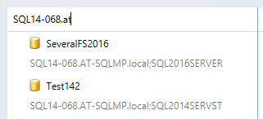
The user can search objects in the instance view by path and by name if “Show instance path” checkbox is switched on. To perform a search, start typing the name of the object in “Filter” field.

Note that the user can search objects in the instance view by name only if “Show instance path” checkbox is switched off.

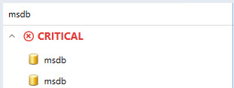

The user can search objects in the instance view by any part of the object path and by any part of the object name.

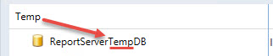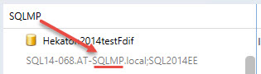

Path line of an object without a path is hidden; path lines of all other instances are displayed.

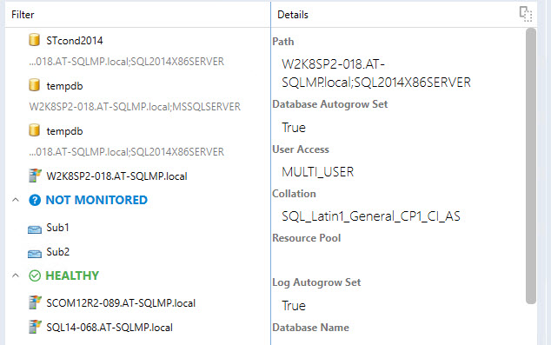

A tooltip with object name and object path appears when the user hovers over the dashboard object, and “Show instance path” checkbox is switched on/off.

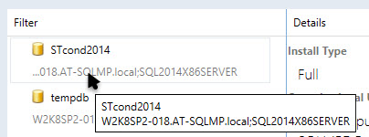

A tooltip with object name appears only when the user hovers over the dashboard object with empty path line.
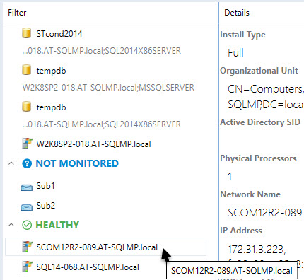

The “Filter” field is cleared every time the user changes the dashboard level.
The user can use filter field even if the dashboard group has objects with empty path line and objects with path at path line simultaneously.

Configure Run As Profiles
When the Management Pack is imported for the first time, it creates a new Microsoft SQL Server Visualization Library Run As Profile, which allows creating low privilege environments for System Center Operations Manager.

To configure permissions on the System Center Operations Manager Management Server:
- Create SSVISLIB account on the domain controller.
- Grant Local Administrator permissions to SSVISLIB account.

To configure permissions on the System Center Operations Manager:
- Open SCOM console and navigate to “Administration” pane.
- Select “User Roles” view (located under “Security” folder).
- Right click on “Operations Manager Operators” role and click “Properties” in the context menu.
- In the “General Properties” tab, click “Add” button.
- Find SSVISLIB user and click “OK”.
- Click “OK” button to apply the changes, and close “User Role Properties” dialog.

Known Issues and Troubleshooting

Configuration of signed SQL Server Dashboards cannot be saved if Default Management Pack is removed
Issue: Signed SQL Server Dashboards store their configuration changes in Default Management Pack (Microsoft.SystemCenter.OperationsManager.DefaultUser).
Resolution: Import Default Management Pack. In further versions of the MP, it will be possible to set a custom MP to store the configuration.

SQL Server Dashboards may display obsolete data
Issue: The Operations Manager database should be synchronized with Data Warehouse. If the default synchronizing procedure has not been executed for a long period, the Dashboards become unable to get the most recent data.
Resolution: Restart System Center Data Access service and perform other required actions to reactivate Delta Synchronization.

The Operations Manager console may crash in case of SCOM server connection failure
Issue: If the Operations Manager console loses connection to SCOM server, SQL Server Dashboards may crash. It can happen due to network issues or SCOM server issues (e.g. if the console is left unattended for a long time).
Resolution: Check connection with SCOM server. Reopen the Operations Manager console.

When configuration of a SQL Server Dashboards is edited simultaneously by a few operators, the last change is applied only
Issue: When a user edits SQL Server Dashboard from the Operations Manager console and Web console simultaneously, the “Last changes apply” algorithm is implemented to resolve this situation.
Resolution: Reopen the Dashboard, or wait until the data is refreshed.

The Operations Manager console may behave unresponsive in case of a configuration save failure
Issue: In some rare cases, SCOM is unable to save updated Dashboard configuration successfully. In this case, dialogs on SQL Server Dashboards become unresponsive (e.g. OK button in “Add Group” dialog). The user can find error details in Application event log.
Resolution: Reopen the Operations Manager console.

Objects may be displayed with “Not monitored” state in case if there are 1000 objects or more
Issue: When there are 1000 objects or more discovered simultaneously (and the discovery process is not over yet), the Dashboard may be loaded correctly, but all objects will have “Not monitored” state.
Resolution: Wait until the data is refreshed.

Alerts may be displayed with “0” value in case if there are 5000 objects or more
Issue: When there are approximately 5000 objects or more discovered simultaneously (and the discovery process is not over yet), it is possible that the number of objects will be loaded and displayed correctly, but the alerts will be displayed with 0 value.
Resolution: Wait until the data is refreshed.

Silverlight version of the Operations Manager console may not receive remote changes
Issue: Any changes made in Silverlight version of the Operations Manager console from a remote workstation may not be saved.
Resolution: Reopening of the Dashboard or reloading of the console is ineffective. To apply any changes, please access the console directly.

Usage of some special Windows themes may lead to a crash of the Operations Manager console
Issue: Some changes in Windows color scheme (e.g. changing of foreground text color to another color) may lead to a crash of the Operations Manager console.
Resolution: Please use standard Windows themes and text colors.

Procedures are not deleted from data warehouse storage
Issue: The stored procedures may remain in data warehouse storage even after uninstallation of GPMP.
Resolution: After uninstallation of the manager packs, the stored procedures are to be deleted manually.

Timeouts difficulty
Issue: While working with the Dashboard (especially while processing large data volumes), a user may face a situation when the processes cannot be completed within the preset timeout.
Resolution: Timeout values for queries execution in Datawarehouse DB may be set by the user manually via the server registry. One can create “HKLM\SOFTWARE\Microsoft\Microsoft Operations Manager\3.0\Data Warehouse” key and add REG_DWORD type value with “Search Command Timeout Seconds” name. The server will use this value instead of default 180 seconds.

Certain display problems may occur while working with the groups in web version of the Operations Manager console
Issue: A problem with displaying add/delete forms may occur while using Silverlight web version of the Operations Manager console: the text of the form may be loaded earlier than the form itself, if the Dashboard contains eight or more groups.
Resolution: Unknown.

Certain problems may occur while working with some older versions of the Management Pack
Issue: The following versions of SQL Server Management Pack are considered as deprecated and suspended:
- 6.1.314.35
- 6.1.400.0
- 6.3.173.0
- 6.3.173.1
- 6.4.0.0
- 6.4.1.0
- 6.5.1.0
- 6.5.4.0
- 6.6.0.0
- 6.6.2.0
- 6.6.3.0
Resolution: Please use up-to-date versions of the Management Pack (starting from version 6.6.4.0)

Dashboards may work slowly if used rarely
Issue: When used rarely or after a long break, the dashboards may work rather slowly due to large amounts of the collected data to be processed; especially, it is related to large environments (2000+ objects).
Resolution: Below is a “warming up” script, which may be used to create an SQL job to run on some schedule. Before scheduling it as an SQL job, please test how long these queries will be executing (if you schedule it to run too often, it may affect the server performance). If you have dashboards with thousands of objects to load, then time to load the content will be 10+ seconds anyway. It was tested with 600 000 objects, and the dashboard loading time was 1-2 minutes.
USE [OperationsManagerDW]
EXECUTE [sdk].[Microsoft_SQLServer_Visualization_Library_UpdateLastValues]
EXECUTE [sdk].[Microsoft_SQLServer_Visualization_Library_UpdateHierarchy]

Dashboards may crash upon upgrade
Issue: In some cases, upon upgrade of the dashboards to version 6.6.7.30 or newer, the Operations Manager console may crash with “ObjectNotFoundException” error.
Resolution: Wait until the importing process is completed, and restart the Operations Manager console. Mind that the Operations Manager console restarting is essential after upgrade of the dashboards. Otherwise, the dashboards will not work.

Colors in Microsoft Silverlight may be assigned incorrectly
Issue: ComboBox colors and main ScrollViewer background may be displayed incorrectly, especially in the dark theme.
Resolution: Unknown.

Certain issues may appear during rapid changes performed in Datacenter view
Issue: If user rapidly changes datacenter dashboard views while the loader is displayed, the last selected view can still be opened, but the queries of the previously closed views will not be cancelled.
Resolution: Unknown.

Dashboards may get stuck while loading
Issue: When there are more than 50K objects on a Dashboard monitored by multi-instance performance collection rules, Datawarehouse DB statistics may get broken, and the Dashboard loading time could get much longer than usual. Moreover, extensive TempDB and Log space usage (~2-5 GB) can be noticed.
Resolution: Wait for some time until the Dashboard is loaded, then run sp_updatestats stored procedure in Datawarehouse DB.

Outdated group names may be displayed in the Instance view
Issue: If a group is renamed, or any already renamed groups are present in SCOM, the old group names may be displayed in SQL Server Dashboards Instance view. In addition, if some groups are renamed in SCOM after importing the dashboards, their old names may be still displayed in the Instance view.
Resolution: Unknown.

Limited access role users may not see SQL instances on SQL Server Roles dashboard
Issue: If a user is assigned to a limited access role (e.g. with access to SSAS Instance group, SSRS Instance Group, and SQL Server DB Engine Group only), no SQL instances are visible on SQL Server Roles dashboard.
Resolution: As long as SQL Server Roles dashboard is currently based on Server Roles Group, the user should obtain access to "Server Roles Group" to make SQL instances visible on the dashboard.

Datacenter view dashboard refresh animation is not displayed
Issue: When the Datacenter view dashboard is refreshed by means of the corresponding button in the hamburger drop-down menu, no refresh animation is displayed.
Resolution: Unknown.

